***PROJECT REPORT***

***ON***

***“CRIME FILE MANAGEMENT”***



**SUBMITTED TO:- SUBMITTED BY:-**

**HOD CSE Vinita Bajaj (1544743)**

**DEPARTMENT OF COMPUTER SCIENCE & ENGINEERING**

**AMRITSAR GROUP OF COLLEGES**

**(Autonomous College, NBA Accredited, NAAC Accredited)**

**INDEX**

|  |  |  |
| --- | --- | --- |
| **S.no** | **Name** | **Page no.** |
| 1 | Introduction |  |
| 2 | Company Overview |  |
| 3 | Existing System |  |
| 4 | Proposed System |  |
| 5  5.1  5.2  5.3  5.4  5.5  5.6  5.7  5.8 | System Development Process  System analyses  Feasibility study  Design  Code Details  Implementation of project  Training/User Training  Operational Document  System Maintanance |  |
| 6 | Data Flow Diagram |  |
| 7 | Database Design |  |
| 8 | Table Structure |  |
| 9 | Software Environment |  |
| 10 | Software and Hardware Specification |  |
| 11 | Screen Shots |  |
| 12 | Conclusion |  |
| 13 | Scope For Future Enhancement |  |
| 14 | Bibliography |  |

1. **Introduction**

The project titled as **“Online Crime File Management“**is a web based application. This software provides facility for reporting online crimes, complaints, missing persons, showmostwanted person. Any Number of clients can connect to the server. Each user first makes their login to sever to show their availability. The server can be any Web Server.

The main modules in this project are:

**Modules**

* Visitors
* Registered Users
* Administrator

**The visitor module includes:**

* View Hotnews: This module help the visitor to see the latest hotnews which can updated by the admin.

**The registered user module includes:**

* Add Complaint: This module help the user to report online complaints.
* Add Crime report: This module help the user to report online crimes.
* Add Missing person: This module help the user to report online missing persons details also we have to add photos of missing person using hetrogenious database.
* View Missing persons: This module help the user to view all the missing person details.
* View Mostwanted persons: This module help the user to view all mostwanted persons which can be given by the administrator.
* Edit Complaint: This module help the user to edit his complaint details.
* Edit Account: This module help the user to update his or her profile.
* View complaint status: This module allows us to view the status of all complaint that you have posted earlier.
* View crime status: This module allows us to view the status of the all crimes that you have posted earlier.
* Add and View feedback: This module helps the user to add and view feedbacks

**The administrator module includes:**

* View and reply user complaint: This module helps the admin to view and reply user’s complaint details
* View and reply user crimes: This module helps the admin to view and reply user’s crimes details
* New admin: This module used for add new admin
* Add and delete latest hotnews: This module helps the admin to add and delete latest hotnews.
* View and delete user’s feedback: This module helps the amin to add and delete user’s feedback
* Add, delete and view mostwanted persons: This module helps the amin to add, delete and view mostwanted person details
* Add, delete and view missing persons: This module helps the amin to add, delete and view missing person details
* Add and view Criminal registeration: This module helps the amin to add and view criminal registrations
* Add and view FIR: This module helps the amin to add and view Fir reports
* Add and view history sheet: This module helps the amin to add and view history reports
* View and delete all complaint reply: This module helps the amin to view and delete complaint reply.
* Add and view prisoner report: This module helps the amin to add and prisoner reports
* Change password: This module helps the amin to update his or her password

1. **Company Overview**

**Neptune Solutions** is a Software and Web Development Company which provides technology solutions and professional software for clients worldwide. Neptunefocus on quality, innovations and leverage deep industry and functional expertise to help customers to transform their highest-value business processes.

Our in depth technical knowledge coupled with industry experience and the unique methodology enables us to successfully deliver the services to the clients worldwide. We are driven to attain our customer's highest satisfaction by providing business experts with underlying delivery expertise in Enterprise Technology, Methodologies and Implementations. Our core competencies are designed to effectively deliver results to our customers.

Neptune Training Center provides premier instructor led IT training through a carefully balanced blend of hands on lab exercises and lecture. Training is conducted in the comfortable classrooms at our training facility and client locations. Experienced instructors make training productive and enjoyable. Customizable courses and computer lab offer additional options for your training needs. We also provide project guidance for all academic students which help them to build a successful portfolio and start their IT journey successfully.

1. **Existing System**

In the existing system only we can see the details of particular information about the police stations in our state, the existing system has more workload for the authorized person, but in the case of Proposed System, the user can registered in our site and send the crime report and complaint about a particular city or person.

**Drawbacks of Existing System**

* More man power.
* Time consuming.
* Consumes large volume of pare work.
* Needs manual calculations.
* No direct role for the higher officials.
* Damage of machines due to lack of attention.

To avoid all these limitations and make the working more accurately the system needs to be computerized.

1. **Proposed System**

The aim of proposed system is to develop a system of improved facilities. The proposed system can overcome all the limitations of the existing system. The system provides proper security and reduces the manual work. The existing system has several disadvantages and many more difficulties to work well. The proposed system tries to eliminate or reduce these difficulties up to some extent. The proposed system will help the user to reduce the workload and mental conflict. The proposed system helps the user to work user friendly and he can easily do his jobs without time lagging.

**Expected Advantages of Proposed System**

The system is very simple in design and to implement. The system requires very low system resources and the system will work in almost all configurations. It has got following features

* Ensure data accuracy’s.
* Proper control of the higher officials.
* Reduce the damages of the machines.
* Minimize manual data entry.
* Minimum time needed for the various processing.
* Greater efficiency.
* Better service.
* User friendliness and interactive.
* Minimum time required.

**5. System Development Process**

**5.1. SYSTEM ANALYSIS**

System analysis is a process of gathering and interpreting facts, diagnosing problems and the information to recommend improvements on the system. It is a problem solving activity that requires intensive communication between the system users and system developers. System analysis or study is an important phase of any system development process. The system is studied to the minutest detail and analyzed. The system analyst plays the role of the interrogator and dwells deep into the working of the present system. The system is viewed as a whole and the input to the system are identified. The outputs from the organizations are traced to the various processes. System analysis is concerned with becoming aware of the problem, identifying the relevant and decisional variables, analyzing and synthesizing the various factors and determining an optimal or at least a satisfactory solution or program of action.

       A detailed study of the process must be made by various techniques like interviews, questionnaires etc. The data collected by these sources must be scrutinized to arrive to a conclusion. The conclusion is an understanding of how the system functions. This system is called the existing system. Now the existing system is subjected to close study and problem areas are identified. The designer now functions as a problem solver and tries to sort out the difficulties that the enterprise faces. The solutions are given as proposals. The proposal is then weighed with the existing system analytically and the best one is selected. The proposal is presented to the user for an endorsement by the user. The proposal is reviewed on user request and suitable changes are made. This is loop that ends as soon as the user is satisfied with proposal.

       Preliminary study is the process of gathering and interpreting facts, using the information for further studies on the system. Preliminary study is problem solving activity that requires intensive communication between the system users and system developers. It does various feasibility studies. In these studies a rough figure of the system activities can be obtained, from which the decision about the strategies to be followed for effective system study and analysis can be taken.

    Here in the Email to Fax server project, a detailed study of existing system is carried along with all the steps in system analysis. An idea for creating a better project was carried and the next steps were followed.

**5.2.FEASIBILITY STUDY**

Feasibility study is made to see if the project on completion will serve the purpose of the organization for the amount of work, effort and the time that spend on it. Feasibility study lets the developer foresee the future of the project and the usefulness. A feasibility study of a system proposal is according to its workability, which is the impact on the organization, ability to meet their user needs and effective use of resources. Thus when a new application is proposed it normally goes through a feasibility study before it is approved for development.

The document provide the feasibility of the project that is being designed and lists various areas that were considered very carefully during the feasibility study of this project such as Technical, Economic and Operational feasibilities.

The following are its features:

* **TECHNICAL FEASIBILITY**

The system must be evaluated from the technical point of view first. The assessment of this feasibility must be based on an outline design of the system requirement in the terms of input, output, programs and procedures. Having identified an outline system, the investigation must go on to suggest the type of equipment, required method developing the system, of running the system once it has been designed.

Technical issues raised during the investigation are:

* Does the existing technology sufficient for the suggested one?
* Can the system expand if developed?

The project should be developed such that the necessary functions and performance are achieved within the constraints. The project is developed within latest technology. Through the technology may become obsolete after some period of time, due to the fact that never version of same software supports older versions, the system may still be used. So there are minimal constraints involved with this project. The system has been developed using Java the project is technically feasible for development.

* **ECONOMIC FEASIBILITY**

The developing system must be justified by cost and benefit. Criteria to ensure that effort is concentrated on project, which will give best, return at the earliest. One of the factors, which affect the development of a new system, is the cost it would require.

The following are some of the important financial questions asked during preliminary investigation:

* The costs conduct a full system investigation.
* The cost of the hardware and software.
* The benefits in the form of reduced costs or fewer costly errors.

Since the system is developed as part of project work, there is no manual cost to spend for the proposed system. Also all the resources are already available, it give an indication of the system is economically possible for development.

* **BEHAVIORAL FEASIBILITY**

This includes the following questions:

* Is there sufficient support for the users?
* Will the proposed system cause harm?

The project would be beneficial because it satisfies the objectives when developed and installed. All behavioral aspects are considered carefully and conclude that the project is behaviorally feasible.

**5.3.DESIGN**

Design is the first step into the development phase for any engineered product or system. Design is a creative process. A good design is the key to effective system. The term “design” is defined as “the process of applying various techniques and principles for the purpose of defining a process or a system in sufficient detail to permit its physical realization”. It may be defined as a process of applying various techniques and principles for the purpose of defining a device, a process or a system in sufficient detail to permit its physical realization. Software design sits at the technical kernel of the software engineering process and is applied regardless of the development paradigm that is used. The system design develops the architectural detail required to build a system or product. As in the case of any systematic approach, this software too has undergone the best possible design phase fine tuning all efficiency, performance and accuracy levels. The design phase is a transition from a user oriented document to a document to the programmers or database personnel. System design goes through two phases of development: Logical and Physical Design.

**1.LOGICAL DESIGN:**

The logical flow of a system and define the boundaries of a system. It includes the following steps:

* Reviews the current physical system – its data flows, file content, volumes, Frequencies etc.
* Prepares output specifications– that is, determines the format, content andFrequency of reports.
* Prepares input specifications– format, content and most of the input functions.
* Prepares edit, security and control specifications.
* Specifies the implementation plan.
* Prepares a logical design walk through of the information flow, output, input, Controls and implementation plan.
* Reviews benefits, costs, target dates and system constraints.

**2.PHYSICAL DESIGN:**

Physical system produces the working systems by define the design specifications that tell the programmers exactly what the candidate system must do. It includes the following steps.

* Design the physical system.
* Specify input and output media.
* Design the database and specify backup procedures.
* Design physical information flow through the system and a physical design.
* Plan system implementation.
* Prepare a conversion schedule and target date.
* Determine training procedures, courses and timetable.
* Devise a test and implementation plan and specify any new hardware/software.
* Update benefits , costs , conversion date and system constraints

**Design/Specification activities:**

* Concept formulation.
* Problem understanding.
* High level requirements proposals.
* Feasibility study.
* Requirements engineering.
* Architectural design.

**MODULE DESIGN**

* Visitors
* Registered Users
* Administrator

**The visitor module include:-**

* View hot news: This module help the visitor to see the latest hotness which can updated by the admin.
* The registered user module includes,
* Add Complaint: This module help the user to report online complaints.
* Add Crime report: This module help the user to report online crimes.
* Add Missing person: This module help the user to report online missing persons details also we have to add photos of missing person using hetrogenious database.
* View Missing persons: This module help the user to view all the missing person details.
* View Mostwanted persons: This module help the user to view all mostwanted persons which can be given by the administrator.
* Edit Complaint: This module help the user to edit his complaint details.
* Edit Account: This module help the user to update his or her profile.
* View complaint status: This module allows us to view the status of all complaint that you have posted earlier.
* View crime status: This module allows us to view the status of the all crimes that you have posted earlier.
* Add and View feedback: This module helps the user to add and view feedbacks

**The administrator module includes:-**

* View and reply user complaint: This module helps the admin to view and reply user’s complaint details
* View and reply user crimes: This module helps the admin to view and reply user’s crimes details
* New admin: This module used for add new admin
* Add and delete latest hotnews: This module helps the admin to add and delete latest hotnews.
* View and delete user’s feedback: This module helps the amin to add and delete user’s feedback
* Add, delete and view mostwanted persons: This module helps the amin to add, delete and view mostwanted person details
* Add, delete and view missing persons: This module helps the amin to add, delete and view missing person details
* Add and view Criminal registeration: This module helps the amin to add and view criminal registrations
* Add and view FIR: This module helps the amin to add and view Fir reports
* Add and view history sheet: This module helps the amin to add and view history reports
* View and delete all complaint reply: This module helps the amin to view and delete complaint reply.
* Add and view prisoner report: This module helps the amin to add and prisoner reports
* Change password: This module helps the amin to update his or her password.

**INPUT DESIGN**

The input design is the link between the information system and the user. It comprises the developing specification and procedures for data preparation and those steps are necessary to put transaction data in to a usable form for processing can be achieved by inspecting the computer to read data from a written or printed document or it can occur by having people keying the data directly into the system. The design of input focuses on controlling the amount of input required, controlling the errors, avoiding delay, avoiding extra steps and keeping the process simple. The input is designed in such a way so that it provides security and ease of use with retaining the privacy. Input Design considered the following things:

* What data should be given as input?
* How the data should be arranged or coded?
* The dialog to guide the operating personnel in providing input.
* Methods for preparing input validations and steps to follow when error occur.

**OBJECTIVES OF INPUT DESIGN**

* Input Design is the process of converting a user-oriented description of the input into a computer-based system. This design is important to avoid errors in the data input process and show the correct direction to the management for getting correct information from the computerized system.
* It is achieved by creating user-friendly screens for the data entry to handle large volume of data. The goal of designing input is to make data entry easier and to be free from errors. The data entry screen is designed in such a way that all the data manipulates can be performed. It also provides record viewing facilities.
* When the data is entered it will check for its validity. Data can be entered with the help of screens. Appropriate messages are provided as when needed so that the user will not be in maize of instant. Thus the objective of input design is to create an input layout that is easy to follow.

**OUTPUT DESIGN**

A quality output is one, which meets the requirements of the end user and presents the information clearly. In any system results of processing are communicated to the users and to other system through outputs. In output design it is determined how the information is to be displaced for immediate need and also the hard copy output. It is the most important and direct source information to the user. Efficient and intelligent output design improves the system’s relationship to help user decision-making.

* Designing computer output should proceed in an organized, well thought out manner; the right output must be developed while ensuring that each output element is designed so that people will find the system can use easily and effectively. When analysis design computer output, they should Identify the specific output that is needed to meet the requirements.
* Select methods for presenting information.
* Create document, report, or other formats that contain information produced by the system.

The output form of an information system should accomplish one or more of the following objectives.

* Convey information about past activities, current status or projections of the future.
* Signal important events, opportunities, problems, or warnings.
* Trigger an action / Confirm an action.

# 5.4. CODE DETAILS

The purpose of code is to facilitate the identification, retrieval of the items and information. A code is an oriented collection of symbols design to provide unique identification of an entry or attribute. Code is built with manually exclusive features. Codes in all cases specify object which are physical or on performance characteristics. They are used to give optimal distraction and other information. Codes are used for identifying, accessing, storing and matching records. The codes insure that only one value of the code with a single meaning is correctly applied to give entity or attribute as described in various ways. Code can also be design in a manner easily understood and applied by the user.

##### **Coding Standard**

The standard used in the development of the system is Microsoft Programming standards. It includes naming conversions of variables, constants and objects, standardized formats or labelling and commenting code, spacing, formatting and indenting.

##### **Naming Convention**

Classes’ names and interface names will start with capital letter. The function names will start with small letters and the first letter of each word in the function name will be in capital letter.

##### **Labels and Comments**

Sufficient labels and comments are included in the description of it for the benefits if the developer and other programmers who might examine it later.

**User Interface**

1. For all the entry screen frames are used which will show the type of the user who is currently logged in and the menus.
2. Standard actions are used for standard actions.
3. Same font is related properties are used for similar screens.

The method of implementation and the time scale to be adopted are found out initially. Next the system is tested properly and the users are trained in the new procedures.

**5.5. IMPLEMENTATION OF PROJECT**

Implementation is the stage of the project where the theoretical design is turned into a working system. It can be considered to be the most crucial stage in achieving a successful new system gaining the users confidence that the new system will work and will be effective and accurate. It is primarily concerned with user training and documentation. Conversion usually takes place about the same time the user is being trained or later. Implementation simply means convening a new system design into operation, which is the process of converting a new revised system design into an operational one.

Implementation is the stage of the project where the theoretical design is tuned into a working system. At this stage the main work load, the greatest upheaval and the major impact on the existing system shifts to the user department. If the implementation is not carefully planned and controlled it can create chaos and confusion.

Implementation includes all those activities that take place to convert from the existing system to the new system. The new system may be a totally new, replacing an existing manual or automated system or it may be a modification to an existing system. Proper implementation is essential to provide a reliable system to meet organization requirements. The process of putting the developed system in actual use is called system implementation. This includes all those activities that take place to convert from the old system to the new system. The system can be implemented only after through testing is done and if it is found to be working according to the specifications. The system personnel check the feasibility of the system. The more complex the system being implemented, the more involved will be the system analysis and design effort required to implement the three main aspects: education and training, system testing and changeover.

The implementation state involves the following tasks:

* Careful planning.
* Investigation of system and constraints.
* Design of methods to achieve the changeover.
* Training of the staff in the changeover phase.

**Implementation Procedures**

Implementation of software refers to the final installation of the package in its real environment, to the satisfaction of the intended uses and the operation of the system. In many organizations someone who will not be operating it, will commission the software development project. In the initial stage people doubt about the software but we have to ensure that the resistance does not build up, as one has to make sure that

* The active user must be aware of the benefits of using the new system.
* Their confidence in the software is built up.
* Proper guidance is imparted to the user so that he is comfortable in using the application.

Before going ahead and viewing the system, the user must know that for viewing the result, the server program should be running in the server. If the server object is not up running on the server, the actual process won’t take place.

**5.6. TRANING/USER TRAINING**

User training is designed to prepare the user for testing and converting the system. To achieve the objective and benefits expected from computer based system, it is essential for the people who will be involved to be confident of their role in the new system. As system becomes more complex, the need for training is more important. By user training the user comes to know how to enter data, respond to error messages, interrogate the database and call up routine that will produce reports and perform other necessary functions.

**Training on the Application Software**

After providing the necessary basic training on computer awareness the user will have to be trained on the new application software. This will give the underlying philosophy of the use of the new system such as the screen flow, screen design type of help on the screen, type of errors while entering the data, the corresponding validation check at each entry and the ways to correct the date entered. It should then cover information needed by the specific user/ group to use the system or part of the system while imparting the training of the program on the application. This training may be different across different user groups and across different levels of hierarchy.

**5.7. Operational Document**

Once the implementation plan is decided, it is essential that the user of the system is made familiar and comfortable with the environment. Education involves right atmosphere and motivating the user. A documentation providing the whole operations of the system is being developed in such a way that the user can work with it in well consistent way. The system is developed user friendly so that the user can work the system from the tips given in the application itself. Useful tip and guidance is given inside the application itself to help the user. Users have to be made aware that what can be achieved with the new system and how it increases the performance of the system. The user of the system should be given a general idea of the system before he uses the system.

**5.8. System Maintenance**

Maintenance is the enigma of system development. The maintenance phase of the software cycle is the time in which a software product performs useful work. After a system is successfully implemented, it should be maintained in a proper manner. System maintenance is an important aspect in the software development life cycle.The need for system maintenance is for it to make adaptable to the changes in the system environment. Software maintenance is of course, far more than "FindingMistakes". Maintenance may be defined by describing four activities that are undertaken after a program is released for use.

**6.Data Flow Diagram**

CONTENT FLOW DIAGRAM

User

Administrator

UserID, Complaints

Complaint Management

Solutions, Feedback

LEVEL 1 DFD ADMINISTRATOR

Add FIR Reports

Add mortem analysis

View Complaints

View user details

View Feedback

User name, Password

Administrator

User

Registration details

Complaints

Feedback

Add Solutions

FIR

Mortem Details

LEVEL 2 DFD ADMINISTRATOR

View Reports

Add Reports

FIR No: Details

FIR Details

Complaint Details

Complaints

FIR

Mortem details

Reports

Administrator

User

Mortem Details

LEVEL 1 DFD- USER

Verify

Complaints

Username/Password

Registration

Login

Complaints

Username/Password

User

LEVEL 2 DFD- USER

Solutions

Complaint Details

Complaint Status

Complaint ID

User name Password

User

Complaint

Feedback

Complaint Status

**7. DATABASE DESIGN**

A database is an organized mechanism that has the capability of storing information through which a user can retrieve stored information in an effective and efficient manner. The data is the purpose of any database and must be protected.

The database design is a two level process. In the first step, user requirements are gathered together and a database is designed which will meet these requirements as clearly as possible. This step is called Information Level Design and it is taken independent of any individual DBMS.

In the second step, this Information level design is transferred into a design for the specific DBMS that will be used to implement the system in question. This step is called Physical Level Design, concerned with the characteristics of the specific DBMS that will be used. A database design runs parallel with the system design. The organization of the data in the database is aimed to achieve the following two major objectives:

* Data Integrity
* Data independence

Normalization is the process of decomposing the attributes in an application, which results in a set of tables with very simple structure. The purpose of normalization is to make tables as simple as possible. Normalization is carried out in this system for the following reasons.

* + To structure the data so that there is no repetition of data , this helps insaving.
  + To permit simple retrieval of data in response to query and report request.
  + To simplify the maintenance of the data through updates, insertions, deletions.
  + To reduce the need to restructure or reorganize data which new application Requirements arise.

**RELATIONAL DATABASE MANAGEMENT SYSTEM (RDBMS)**

A relational model represents the database as a collection of relations. Each relation resembles a table of values or file of records. In formal relational model terminology, a row is called a tuple, a column header is called an attribute and the table is called a relation. A relational database consists of a collection of tables, each of which is assigned a unique name. A row in a tale represents a set of related values.

**RELATIONS, DOMAINS & ATTRIBUTES:**

A table is a relation. The rows in a table are called tuples. A tuple is an ordered set of n elements. Columns are referred to as attributes. Relationships have been set between every table in the database. This ensures both Referential and Entity Relationship Integrity. A domain D is a set of atomic values. A common method of specifying a domain is to specify a data type from which the data values forming the domain are drawn. It is also useful to specify a name for the domain to help in interpreting its values. Every value in a relation is atomic, that is not decomposable.

## RELATIONSHIPS:

* Table relationships are established using Key. The two main keys of prime importance are Primary Key & Foreign Key. Entity Integrity and Referential Integrity Relationships can be established with these keys.
* Entity Integrity enforces that no Primary Key can have null values.
* Referential Integrity enforces that no Primary Key can have null values.
* Referential Integrity for each distinct Foreign Key value, there must exist a matching Primary Key value in the same domain. Other key are Super Key and Candidate Keys.
* Relationships have been set between every table in the database. This ensures both Referential and Entity Relationship Integrity.

## NORMALIZATION:

## As the name implies, it denoted putting things in the normal form. The application developer via normalization tries to achieve a sensible organization of data into proper tables and columns and where names can be easily correlated to the data by the user. Normalization eliminates repeating groups at data and thereby avoids data redundancy which proves to be a great burden on the computer resources. These includes:

* Normalize the data.
* Choose proper names for the tables and columns.
* Choose the proper name for the data.

**First Normal Form**:

The First Normal Form states that the domain of an attribute must include only atomic values and that the value of any attribute in a tuple must be a single value from the domain of that attribute. In other words 1NF disallows “relations within relations” or “relations as attribute values within tuples”. The only attribute values permitted by 1NF are single atomic or indivisible values.

The first step is to put the data into First Normal Form. This can be donor by moving data into separate tables where the data is of similar type in each table. Each table is given a Primary Key or Foreign Key as per requirement of the project. In this we form new relations for each nonatomic attribute or nested relation. This eliminated repeating groups of data.

A relation is said to be in first normal form if only if it satisfies the constraints that contain the primary key only.

**Second Normal Form**:

According to Second Normal Form, for relations where primary key contains multiple attributes, no nonkey attribute should be functionally dependent on a part of the primary key.

In this we decompose and setup a new relation for each partial key with its dependent attributes. Make sure to keep a relation with the original primary key and any attributes that are fully functionally dependent on it. This step helps in taking out data that is only dependant on apart of the key.

A relation is said to be in second normal form if and only if it satisfies all the first normal form conditions for the primary key and every non-primary key attributes of the relation is fully dependent on its primary key alone.

**Third Normal Form**:

According to Third Normal Form, Relation should not have a nonkey attribute functionally determined by another nonkey attribute or by a set of nonkey attributes. That is, there should be no transitive dependency on the primary key.

In this we decompose and set up relation that includes the nonkey attributes that functionally determines other nonkey attributes. This step is taken to get rid of anything that does not depend entirely on the Primary Key.

A relation is said to be in third normal form if only if it is in second normal form and more over the non key attributes of the relation should not be depend on other non key attribute.

**8.tables structure**

**1.TableName: Login**

|  |  |  |  |
| --- | --- | --- | --- |
| **Fieldname** | **Data Type** | **Length** | **Key** |
| Username | varchar | 20 | primary key |
| Password | varchar | 25 | - |
| Status | varchar | 10 | - |

**2.TableName: User Registration**

|  |  |  |  |
| --- | --- | --- | --- |
| **fieldname** | **data type** | **length** | **Key** |
| name | varchar | 20 | - |
| username | varchar | 20 | primary key |
| password | varchar | 20 | - |
| secret question | varchar | 50 | - |
| answer | varchar | 50 | - |
| address | varchar | 50 | - |
| pincode | varchar | 9 | - |
| phone | varchar | 10 | - |
| email | varchar | 30 | - |
| village | varchar | 15 | - |
| taluk | varchar | 15 | - |
| district | varchar | 15 | - |
| state | varchar | 15 | - |

**3.Table Name: Crime Report**

|  |  |  |  |
| --- | --- | --- | --- |
| **Fieldname** | **Data Type** | **Length** | **Key** |
| crime no | varchar | 15 | primary key |
| userid | varchar | 15 | - |
| name of informant | varchar | 15 | - |
| address | varchar | 50 | - |
| details of suspect | varchar | 15 | - |
| description | varchar | 15 | - |
| datec | varchar | 15 | - |

**4.Table Name: Complaint Registration**

|  |  |  |  |
| --- | --- | --- | --- |
| **Fieldname** | **Data Type** | **Length** | **Key** |
| complaintno | varchar | 10 | - |
| userid | varchar | 15 | primary key |
| details of suspect | varchar | 20 | - |
| description | varchar | 25 | - |
| datec | varchar | 20 | - |
| type of crime | varchar | 10 | - |
| others | varchar | 15 | - |

**5.Table Name: Admin Registration**

|  |  |  |  |
| --- | --- | --- | --- |
| **Fieldname** | **Data Type** | **Length** | **Key** |
| username | varchar | 20 | Primary key |
| password | varchar | 20 | - |
| confirm password | varchar | 20 | - |
| secret question | varchar | 50 | - |
| answer | varchar | 50 | - |
| name | varchar | 20 | - |
| designation | varchar | 20 | - |
| official address | varchar | 25 | - |
| phone | varchar | 11 | - |
| residential address | varchar | 25 | - |
| pincode | varchar | 10 | - |
| phone | varchar | 10 | - |
| email | varchar | 30 | - |

**6.Table Name: Prisoners Register**

|  |  |  |  |
| --- | --- | --- | --- |
| **Fieldname** | **Data Type** | **Length** | **Key** |
| prisonerno | varchar | 10 | primary key |
| chargesheetno | varchar | 15 | - |
| nickname | varchar | 15 | - |
| typeofcrime | varchar | 15 | - |
| familymembers | varchar | 20 | - |
| identificationmarks | varchar | 25 | - |
| height | varchar | 15 | - |
| weight | varchar | 15 | - |
| colour | varchar | 10 | - |

**7.Table Name: Criminal Register**

|  |  |  |  |
| --- | --- | --- | --- |
| **Fieldname** | **Data Type** | **Length** | **Key** |
| criminalno | varchar | 10 | primary key |
| name | varchar | 15 | - |
| nickname | varchar | 15 | - |
| age | varchar | 10 | - |
| occupation | varchar | 15 | - |
| crimetype | varchar | 15 | - |
| address | varchar | 15 | - |
| mostwanted | varchar | 15 | - |

**8.Table Name:History Sheet**

|  |  |  |  |
| --- | --- | --- | --- |
| **Fieldname** | **Data Type** | **Length** | **Key** |
| Prisoner | varchar | 15 | primary key |
| type of crime | varchar | 15 | - |
| date of occurrence | varchar | 10 | - |
| place of occurrence | varchar | 15 | - |
| brief of case | varchar | 100 | - |

**9.Table Name:Feedback**

|  |  |  |  |
| --- | --- | --- | --- |
| **Fieldname** | **Data Type** | **Length** | **Key** |
| name | varchar | 15 | - |
| email | varchar | 25 | - |
| message | varchar | 30 | - |

**10.Table Name: Crime Status**

|  |  |  |  |
| --- | --- | --- | --- |
| **Fieldname** | **Data Type** | **Length** | **Key** |
| userid | varchar | 10 | - |
| crimeno | varchar | 10 | primary key |
| viewstatus | varchar | 20 | - |

**11.Table Name: Complaint Status**

|  |  |  |  |
| --- | --- | --- | --- |
| **Fieldname** | **Data Type** | **Length** | **Key** |
| userid | Varchar | 10 | - |
| complaintno | varchar | 10 | primary key |
| viewstatus | Varchar | 20 | - |

**12.TableName: Most Wanted**

|  |  |  |  |
| --- | --- | --- | --- |
| **fieldname** | **data type** | **length** | **Key** |
| name | varchar | 10 | - |
| age | Varchar | 10 | - |
| address | Varchar | 15 | - |
| typeofcrime | Varchar | 10 | - |
| complexion | Varchar | 10 | - |
| hair | Varchar | 15 | - |
| built | Varchar | 20 | - |
| passportno | Varchar | 12 | - |
| casedescription | Varchar | 12 | - |

**13.Table Name: Fir**

|  |  |  |  |
| --- | --- | --- | --- |
| **Fieldname** | **data type** | **length** | **Key** |
| District | varchar | 10 | - |
| Date | varchar | 10 | - |
| Time | varchar | 15 | - |
| Typeofinformation | varchar | 10 | - |
| Placeofoccurence | varchar | 15 | - |
| Foreignlocal | varchar | 15 | - |
| Act | varchar | 10 | - |
| Firno | varchar | 10 | - |
| Section | varchar | 10 | - |
| Diaryrefno | varchar | 15 | - |
| Informantadd | varchar | 15 | - |
| Passportno | varchar | 10 | - |
| Complaintno | varchar | 10 | - |
| Police | varchar | 10 | - |
| Receivdtime | varchar | 10 | - |
| Informationrec | varchar | 10 | - |
| Distancefrompolst | varchar | 10 | - |

**14.TableName: Missing Person**

|  |  |  |  |
| --- | --- | --- | --- |
| **fieldname** | **data type** | **length** | **Key** |
| firno | Varchar | 10 | primary key |
| district | Varchar | 10 | - |
| nameofpol | Varchar | 10 | - |
| datem | Varchar | 20 | - |
| dater | Varchar | 20 | - |
| sex | Varchar | 4 | - |
| age | Varchar | 6 | - |
| complex | Varchar | 10 | - |
| height | Varchar | 5 | - |
| fat | Varchar | 10 | - |
| idmark | Varchar | 10 | - |
| apparels | Varchar | 15 | - |
| namaddr | Varchar | 15 | - |
| bc | Varchar | 14 | - |

# Python

## What is Python?

Python is a popular programming language. It was created by Guido van Rossum, and released in 1991.

It is used for:

* web development (server-side),
* software development,
* mathematics,
* system scripting.

### What can Python do?

* Python can be used on a server to create web applications.
* Python can be used alongside software to create workflows.
* Python can connect to database systems. It can also read and modify files.
* Python can be used to handle big data and perform complex mathematics.
* Python can be used for rapid prototyping, or for production-ready software development.

### Why Python?

* Python works on different platforms (Windows, Mac, Linux, Raspberry Pi, etc).
* Python has a simple syntax similar to the English language.
* Python has syntax that allows developers to write programs with fewer lines than some other programming languages.
* Python runs on an interpreter system, meaning that code can be executed as soon as it is written. This means that prototyping can be very quick.
* Python can be treated in a procedural way, an object-orientated way or a functional way.

### Good to know

* The most recent major version of Python is Python 3, which we shall be using in this tutorial. However, Python 2, although not being updated with anything other than security updates, is still quite popular.
* In this tutorial Python will be written in a text editor. It is possible to write Python in an Integrated Development Environment, such as Thonny, Pycharm, Netbeans or Eclipse which are particularly useful when managing larger collections of Python files.

### Python Syntax compared to other programming languages

* Python was designed for readability, and has some similarities to the English language with influence from mathematics.
* Python uses new lines to complete a command, as opposed to other programming languages which often use semicolons or parentheses.
* Python relies on indentation, using whitespace, to define scope; such as the scope of loops, functions and classes. Other programming languages often use curly-brackets for this purpose.

## Python Install

Many PCs and Macs will have python already installed.

To check if you have python installed on a Windows PC, search in the start bar for Python or run the following on the Command Line (cmd.exe):

C:\Users\Your Name>python --version

To check if you have python installed on a Linux or Mac, then on linux open the command line or on Mac open the Terminal and type:

python --version

If you find that you do not have python installed on your computer, then you can download it for free from the following website: <https://www.python.org/>

## Python Quickstart

Python is an interpreted programming language, this means that as a developer you write Python (.py) files in a text editor and then put those files into the python interpreter to be executed.

The way to run a python file is like this on the command line:

C:\Users\Your Name>python helloworld.py

Where "helloworld.py" is the name of your python file.

Let's write our first Python file, called helloworld.py, which can be done in any text editor.

helloworld.py

print("Hello, World!")

[Run example »](https://www.w3schools.com/python/showpython.asp?filename=demo_helloworld)

Simple as that. Save your file. Open your command line, navigate to the directory where you saved your file, and run:

C:\Users\Your Name>python helloworld.py

The output should read:

Hello, World!

Congratulations, you have written and executed your first Python program.

# Python Syntax

## Execute Python Syntax

As we learned in the previous page, Python syntax can be executed by writing directly in the Command Line:

>>>print("Hello, World!")  
Hello, World!

Or by creating a python file on the server, using the .py file extension, and running it in the Command Line:

C:\Users\Your Name>python myfile.py

## Python Indentations

Where in other programming languages the indentation in code is for readability only, in Python the indentation is very important.

Python uses indentation to indicate a block of code.

### Example

if 5 > 2:  
  print("Five is greater than two!")

[Run example »](https://www.w3schools.com/python/showpython.asp?filename=demo_indentation)

Python will give you an error if you skip the indentation:

### Example

if 5 > 2:  
print("Five is greater than two!")

[Run example »](https://www.w3schools.com/python/showpython.asp?filename=demo_indentation_test)

## Comments

Python has commenting capability for the purpose of in-code documentation.

Comments start with a #, and Python will render the rest of the line as a comment:

### Example

Comments in Python:

#This is a comment.  
print("Hello, World!")

[Run example »](https://www.w3schools.com/python/showpython.asp?filename=demo_comment)

### Docstrings

Python also has extended documentation capability, called docstrings.

Docstrings can be one line, or multiline.

Python uses triple quotes at the beginning and end of the docstring:

### Example

Docstrings are also comments:

"""This is a   
multiline docstring."""  
print("Hello, World!")

[Run example »](https://www.w3schools.com/python/showpython.asp?filename=demo_docstring)

# Python Variables

## Creating Variables

Unlike other programming languages, Python has no command for declaring a variable.

A variable is created the moment you first assign a value to it.

### Example

x = 5  
y = "John"  
print(x)  
print(y)

[Run example »](https://www.w3schools.com/python/showpython.asp?filename=demo_variables1)

Variables do not need to be declared with any particular type and can even change type after they have been set.

### Example

x = 4 # x is of type int  
x = "Sally" # x is now of type str  
print(x)

[Run example »](https://www.w3schools.com/python/showpython.asp?filename=demo_variables2)

## Variable Names

A variable can have a short name (like x and y) or a more descriptive name (age, carname, total_volume). Rules for Python variables:

* A variable name must start with a letter or the underscore character
* A variable name cannot start with a number
* A variable name can only contain alpha-numeric characters and underscores (A-z, 0-9, and _ )
* Variable names are case-sensitive (age, Age and AGE are three different variables)

Remember that variables are case-sensitive

## Output Variables

The Python print statement is often used to output variables.

To combine both text and a variable, Python uses the + character:

### Example

x = "awesome"  
print("Python is " + x)

[Run example »](https://www.w3schools.com/python/showpython.asp?filename=demo_variables3)

You can also use the + character to add a variable to another variable:

### Example

x = "Python is "  
y = "awesome"  
z =  x + y  
print(z)

[Run example »](https://www.w3schools.com/python/showpython.asp?filename=demo_variables4)

For numbers, the + character works as a mathematical operator:

### Example

x = 5  
y = 10  
print(x + y)

[Run example »](https://www.w3schools.com/python/showpython.asp?filename=demo_variables5)

If you try to combine a string and a number, Python will give you an error:

### Example

x = 5  
y = "John"  
print(x + y)

[Run example »](https://www.w3schools.com/python/showpython.asp?filename=demo_variables_test)

# Python – Loops

In general, statements are executed sequentially: The first statement in a function is executed first, followed by the second, and so on. There may be a situation when you need to execute a block of code several number of times.

Programming languages provide various control structures that allow for more complicated execution paths.

A loop statement allows us to execute a statement or group of statements multiple times. The following diagram illustrates a loop statement −

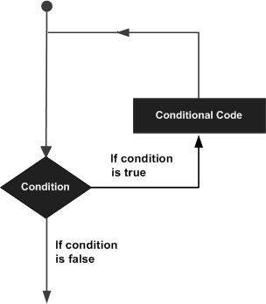

Python programming language provides following types of loops to handle looping requirements.

|  |  |
| --- | --- |
| **Sr.No.** | **Loop Type & Description** |
| 1 | [**while loop**](https://www.tutorialspoint.com/python/python_while_loop.htm)  Repeats a statement or group of statements while a given condition is TRUE. It tests the condition before executing the loop body. |
| 2 | [**for loop**](https://www.tutorialspoint.com/python/python_for_loop.htm)  Executes a sequence of statements multiple times and abbreviates the code that manages the loop variable. |
| 3 | [**nested loops**](https://www.tutorialspoint.com/python/python_nested_loops.htm)  You can use one or more loop inside any another while, for or do..while loop. |

## Loop Control Statements

Loop control statements change execution from its normal sequence. When execution leaves a scope, all automatic objects that were created in that scope are destroyed.

Python supports the following control statements. Click the following links to check their detail.

Let us go through the loop control statements briefly

|  |  |
| --- | --- |
| **Sr.No.** | **Control Statement & Description** |
| 1 | [**break statement**](https://www.tutorialspoint.com/python/python_break_statement.htm)  Terminates the loop statement and transfers execution to the statement immediately following the loop. |
| 2 | [**continue statement**](https://www.tutorialspoint.com/python/python_continue_statement.htm)  Causes the loop to skip the remainder of its body and immediately retest its condition prior to reiterating. |
| 3 | [**pass statement**](https://www.tutorialspoint.com/python/python_pass_statement.htm)  The pass statement in Python is used when a statement is required syntactically but you do not want any command or code to execute. |

**Home Page**:

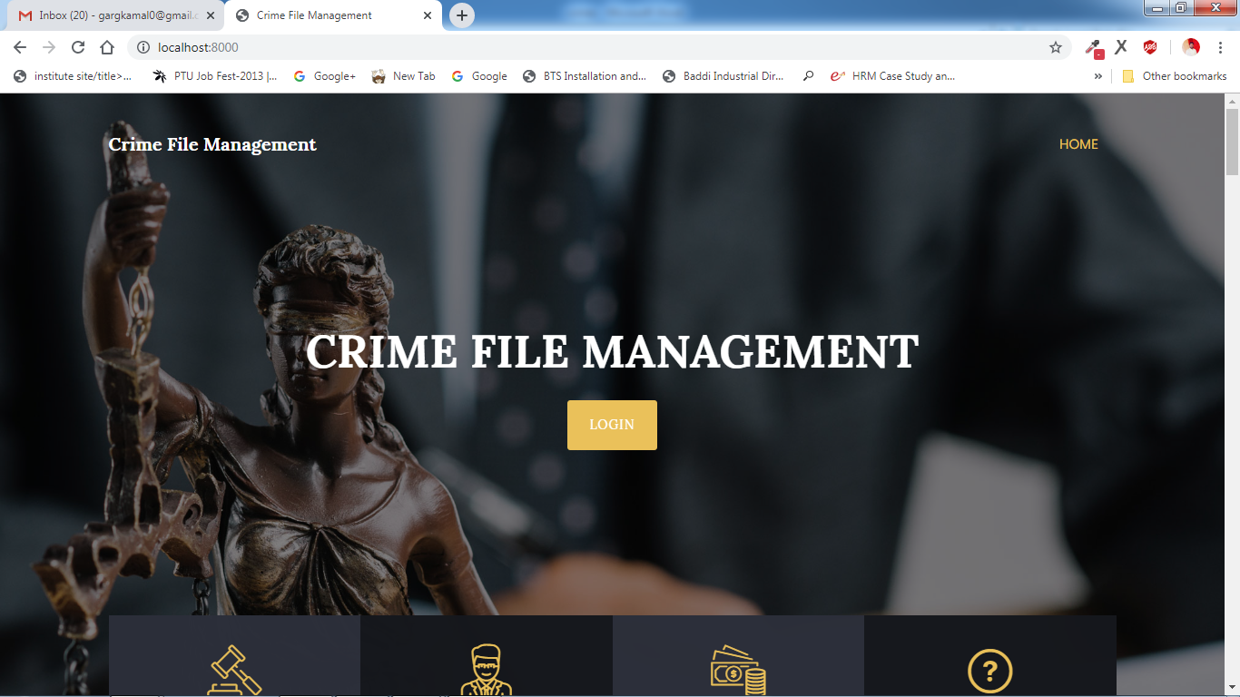

**User Register:**

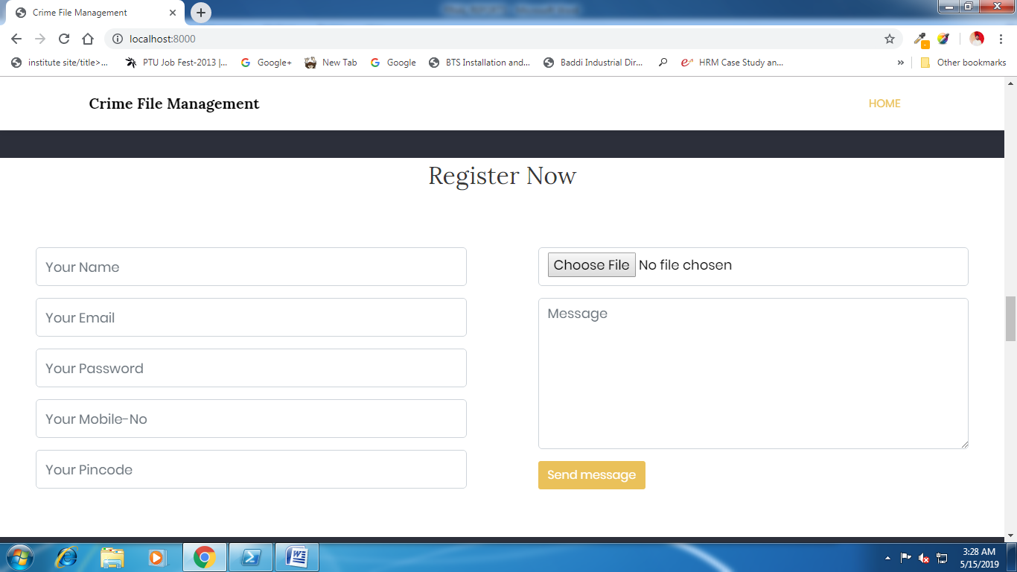

**Login:**

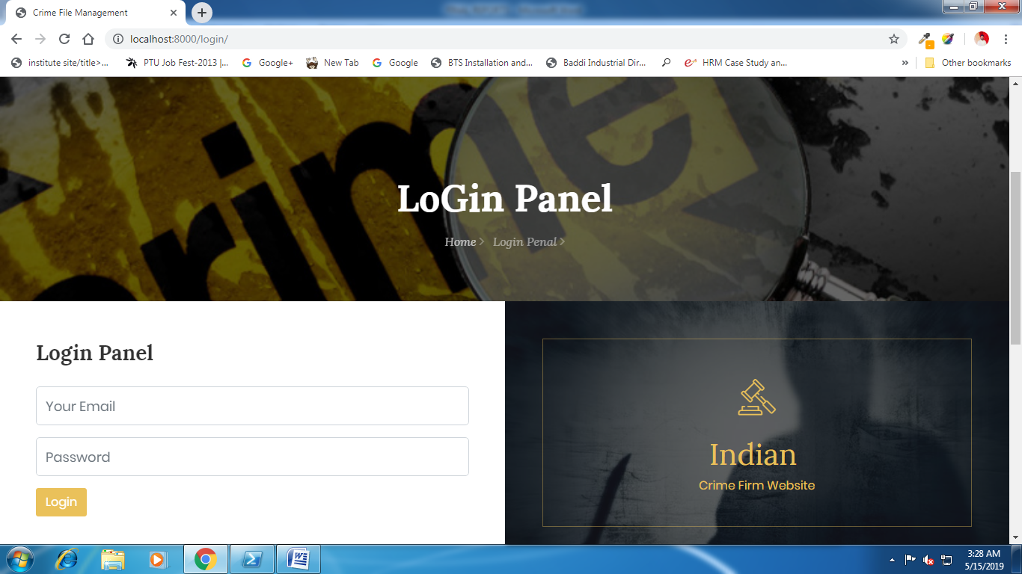

**User Homepage:**

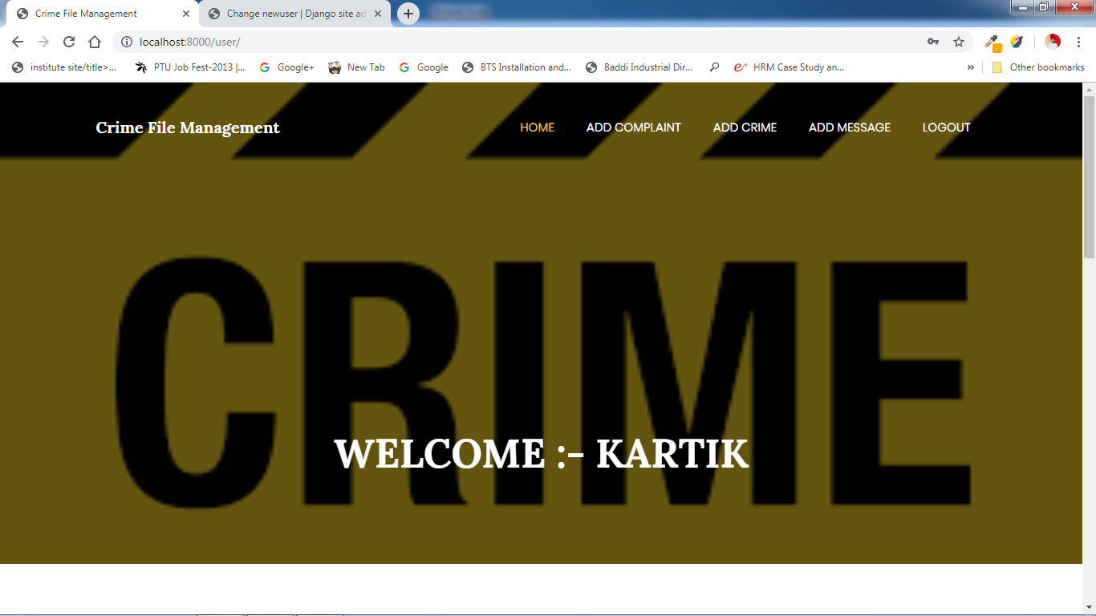

**Complaint Status:**

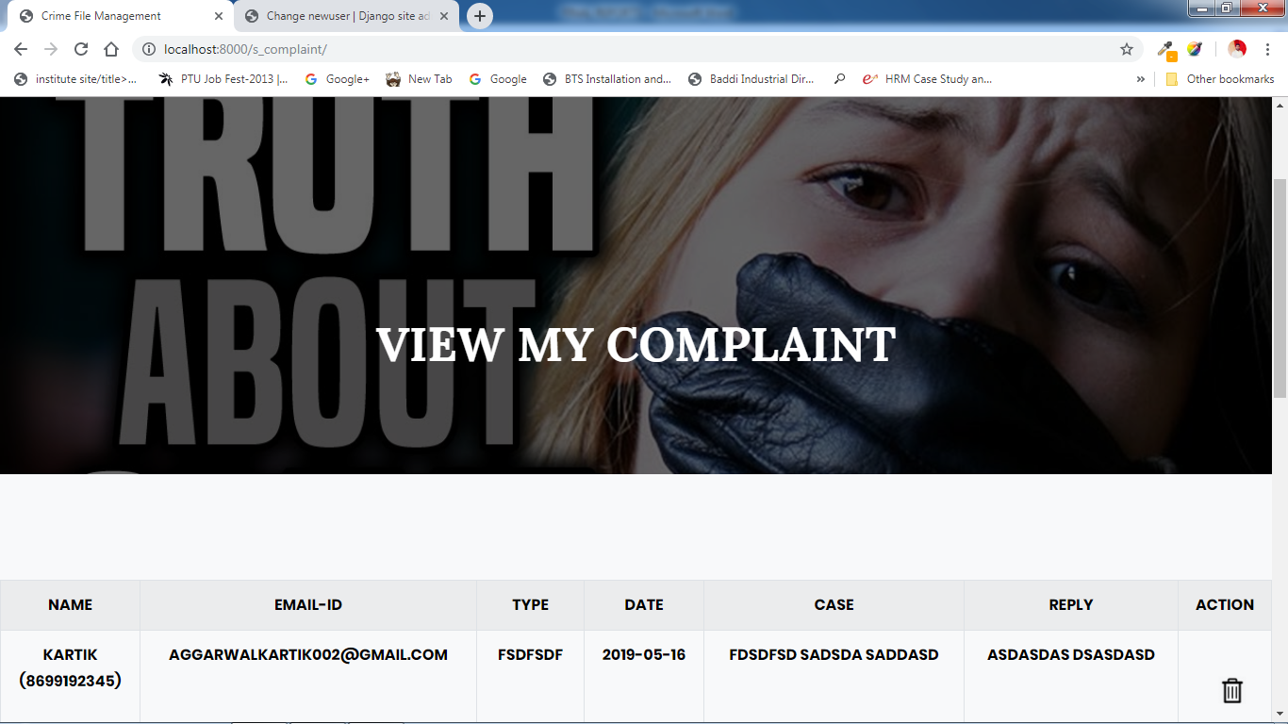

**Crime Report:**

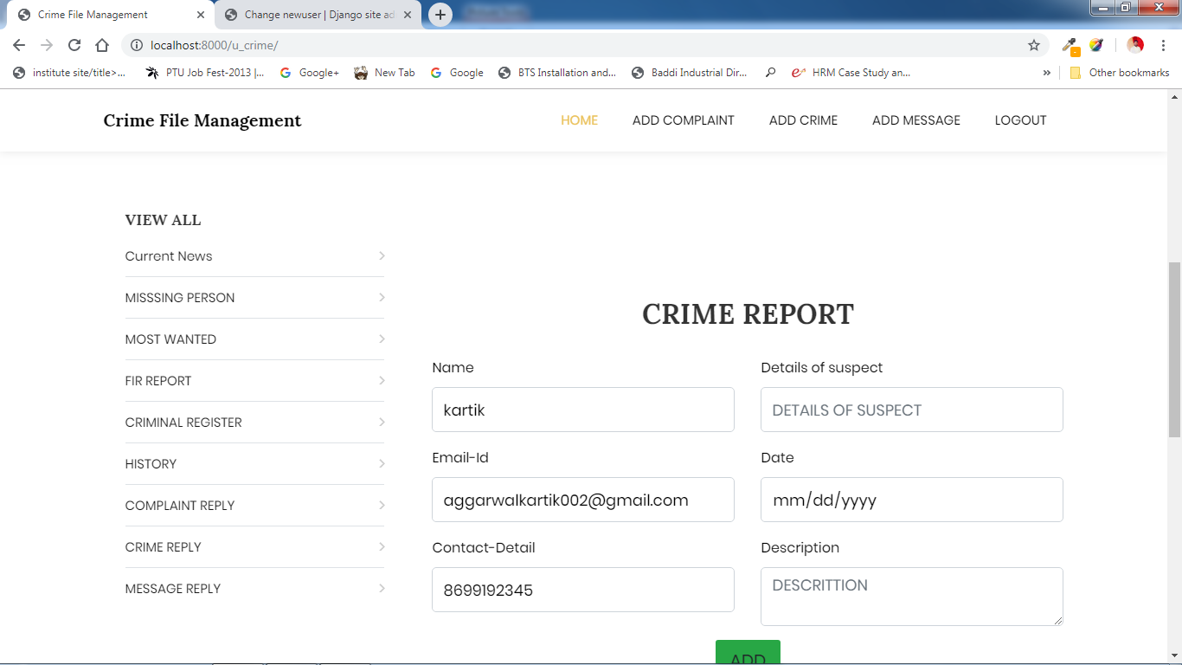

**Missing Person:**

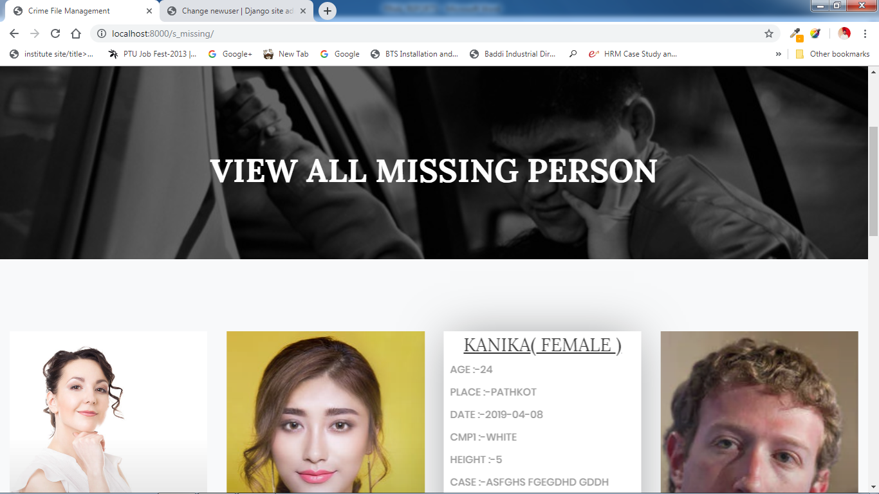

**View Missing details:**

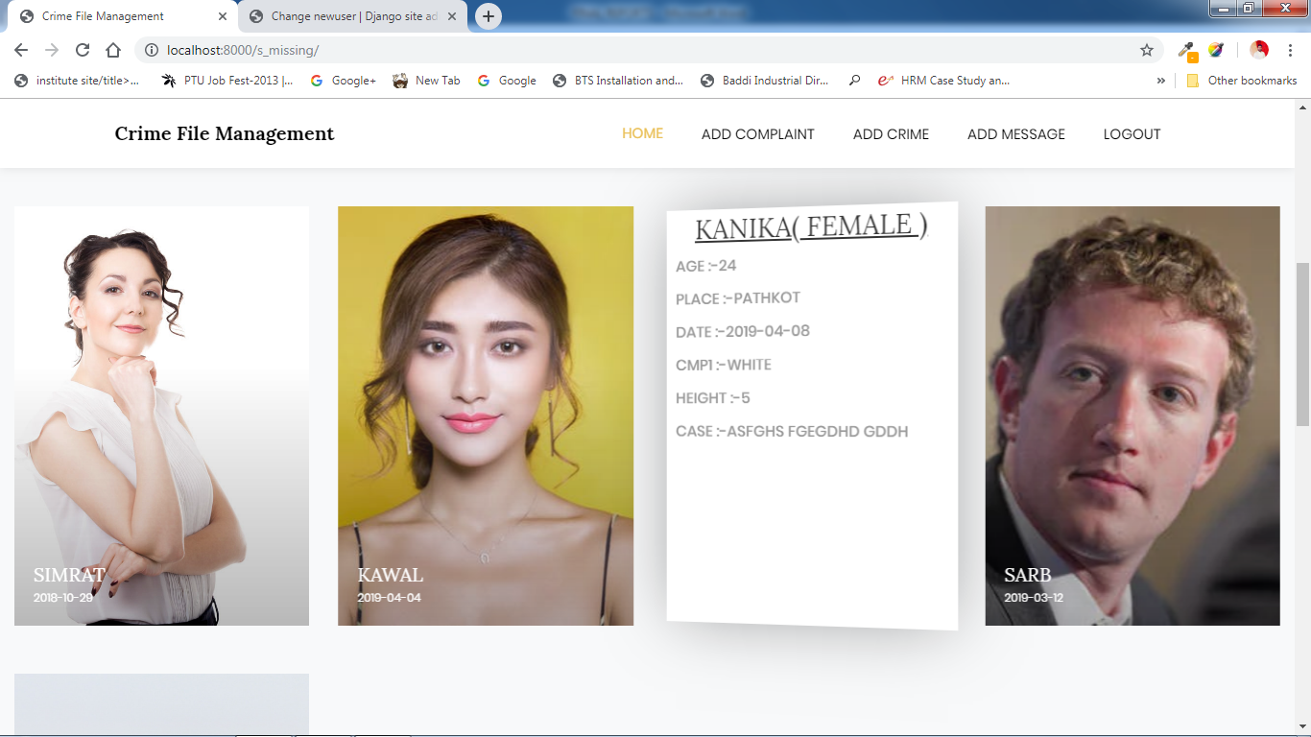

**Admin Homepage:**

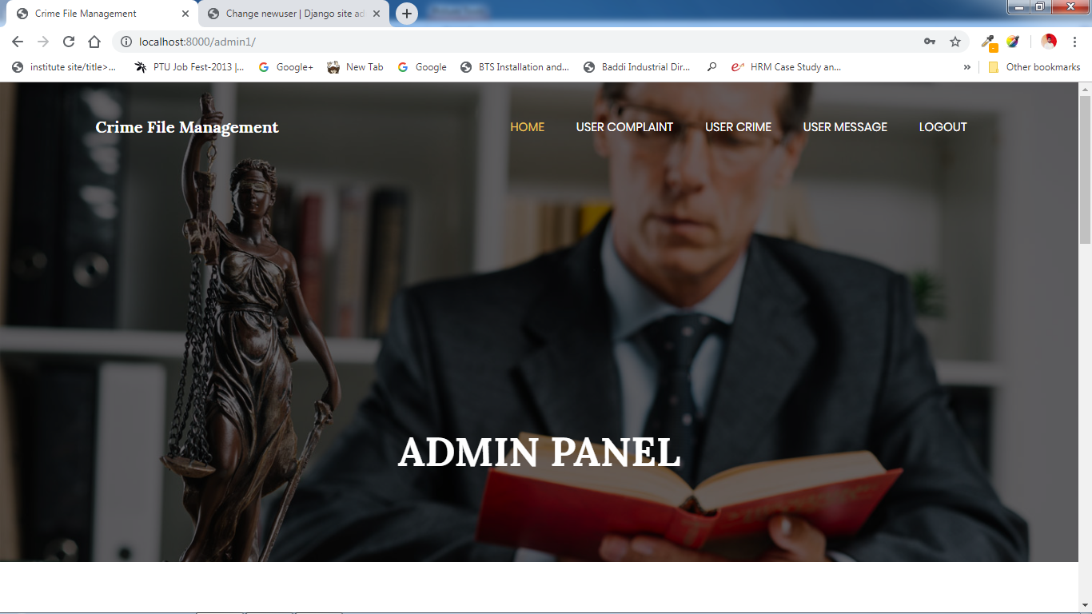

**Criminal Report:**

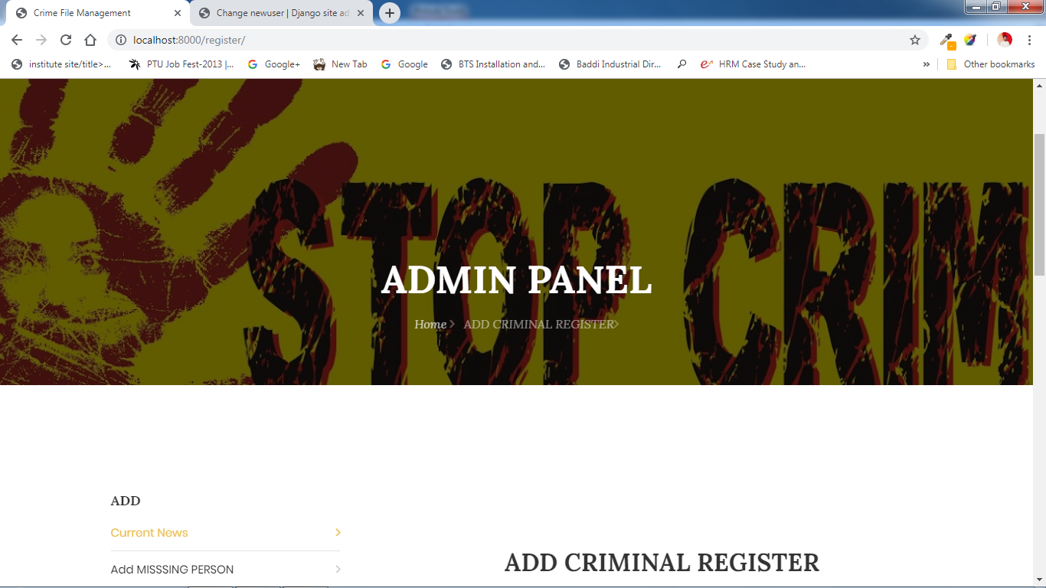

**All Complaint report:**

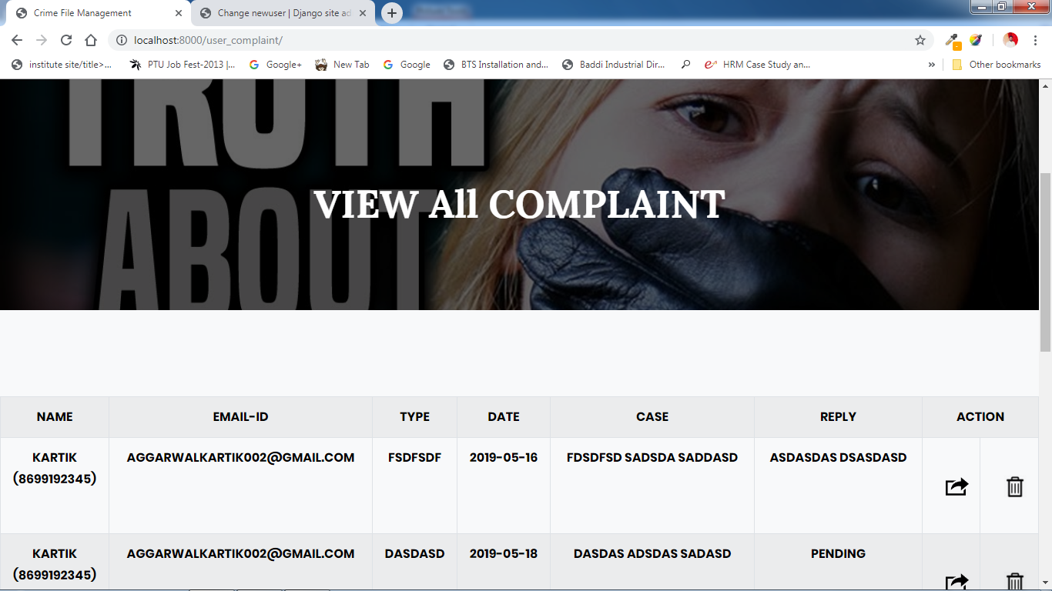

**Mostwanted person:**

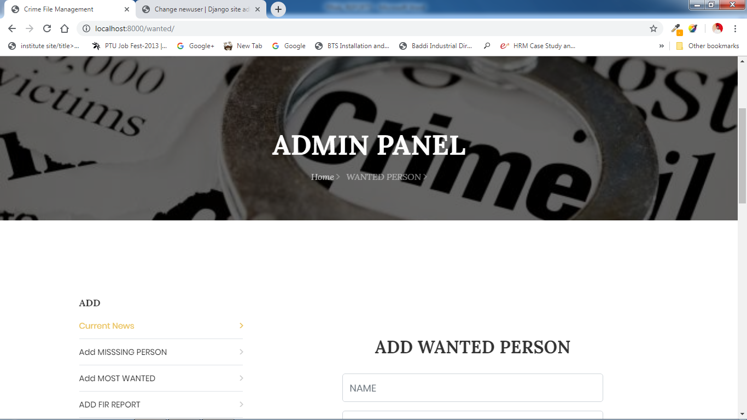

**View and Delete Missing person:**

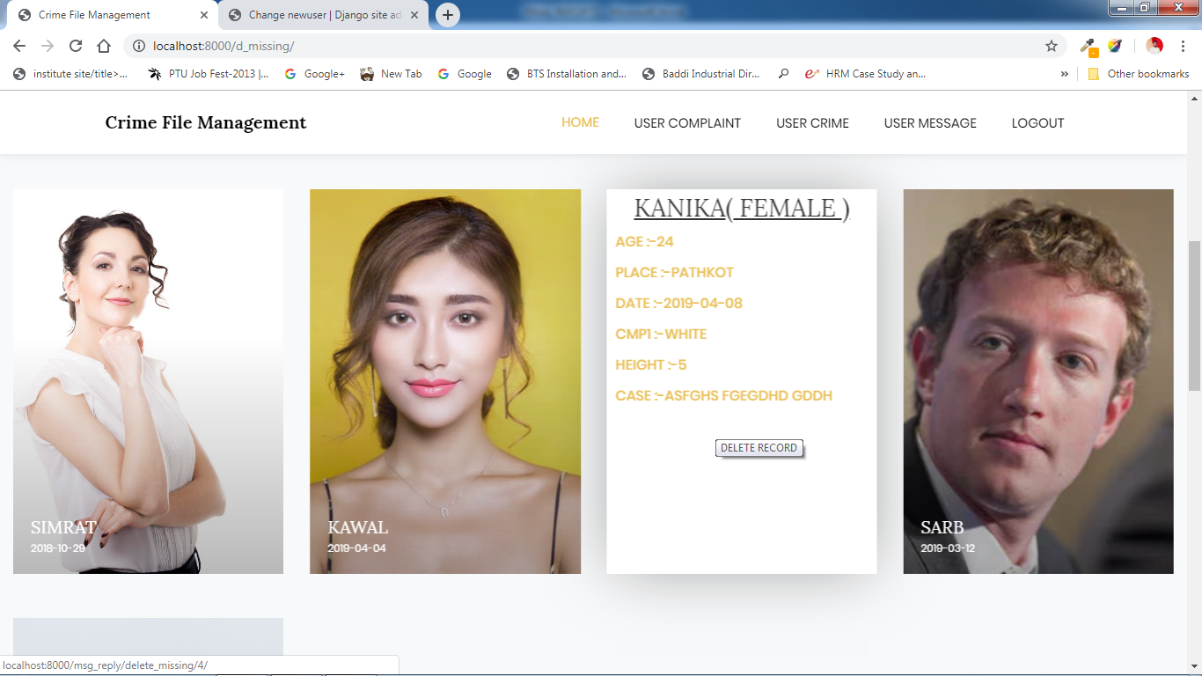

**View and delete Mostwanted Person:**

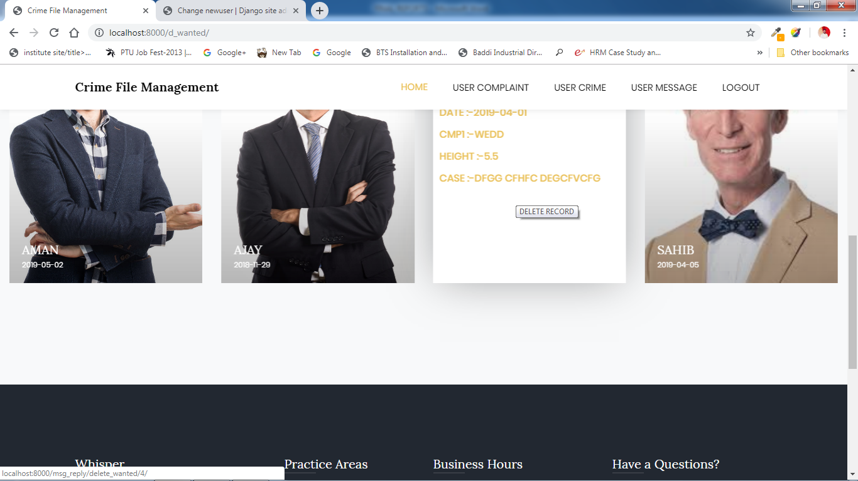

**View and delete hotnews:**

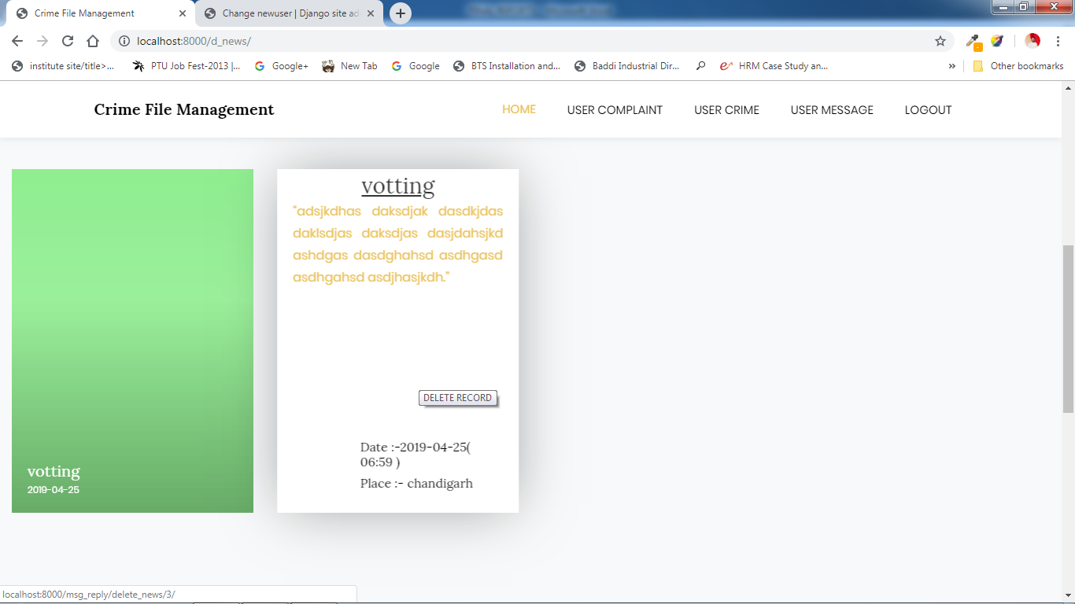

**12. Conclusion**

The project titled as **“Online Crime File Management”** is a web based application. This software provides facility for reporting online crimes, complaints, missing persons, show mostwanted person details mailing as well as chatting. SThis software is developed with scalability in mind. Additional modules can be easily added when necessary. The software is developed with modular approach. All modules in the system have been tested with valid data and invalid data and everything work successfully. Thus the system has fulfilled all the objectives identified and is able to replace the existing system.

The project has been completed successfully with the maximum satisfaction of the organization. The constraints are met and overcome successfully. The system is designed as like it was decided in the design phase. The project gives good idea on developing a full-fledged application satisfying the user requirements.

The system is very flexible and versatile. This software has a user-friendly screen that enables the user to use without any inconvenience. Validation checks induced have greatly reduced errors. Provisions have been made to upgrade the software. The application has been tested with live data and has provided a successful result. Hence the software has proved to work efficiently.

**13. Scope for Future Enhancement**

In future we can use Image recognization instead of using hetrogenious database more over High speed, accuracy and non-redundant data are the main advantages of the proposed system. In the proposed system the user is provided with a choice of data screen, which are similar in formats to the source documents. Data entry errors can be minimized through validity checks. After the verification only the data are placed the permanent database.The software can be developed further to include a lot of modules because the proposed system is developed on the view of future, for example we should develop the system as a database independent using JDBC so we can connect it to any other database, Now the proposed system is based on PC and intranet but in the future if we need to convert it intointernet then we need to change the front end only because we are developing this on the basis of OOP technology and most of the business logic’s are bounded in the class files and module like reusable components.

**14.Bibliography**

BOOKS:

* Press
* Ian Somerville ‘Software engineering’
* Rajeev mall ‘Software engineering’
* ElmasriNavathe ‘Fundamentals of database systems’